4. Project Planning Phase
Objective

To prepare a systematic plan for developing, testing, documenting, and demonstrating the Auto Ticket Classification system using Flow Designer.

Activities Performed

- Define the project scope.
- Identify the major tasks involved in the project.
- Divide the project into different development activities.
- Identify the Flow Designer components required.
- Plan the ticket classification rules.
- Plan category and support group mapping.
- Plan development and configuration activities.
- Prepare a testing plan.
- Identify possible errors and unmatched ticket conditions.
- Plan project documentation.
- Plan the final project demonstration.

Project Tasks

Phase| Planned Activity
Requirement| Identify ticket fields and classification rules
Design| Design the automated workflow
Development| Create and configure the Flow Designer flow
Testing| Test different ticket categories
Documentation| Prepare project documentation
Demonstration| Demonstrate the complete workflow

Resource Planning

The project requires:

- ServiceNow environment
- Flow Designer
- Support ticket table
- Ticket classification conditions
- Appropriate categories
- Assignment groups
- Test ticket records

Risk Identification

Possible issues identified during planning include:

- Incorrect classification conditions.
- Missing ticket information.
- Tickets not matching predefined conditions.
- Incorrect assignment group configuration.
- Flow execution errors.

Expected / Produced Output

The project planning phase produces a structured development plan covering:

Requirement → Design → Development → Testing → Documentation → Demonstration

Screenshots

Screenshot 1
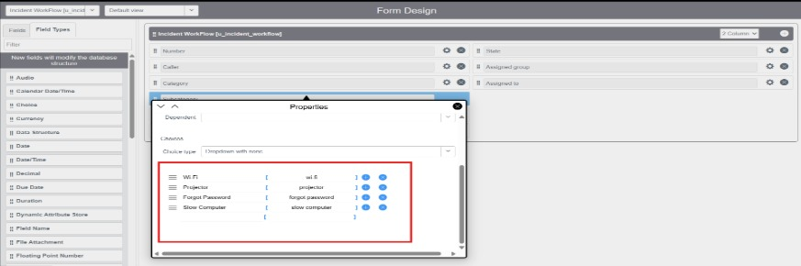
Screenshot 2
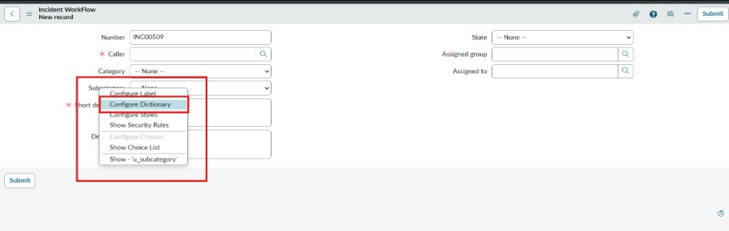
Screenshot 3
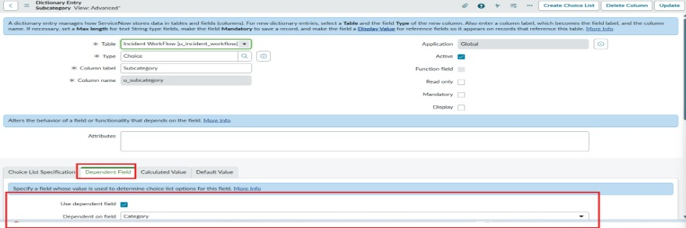

Data Flow Diagram
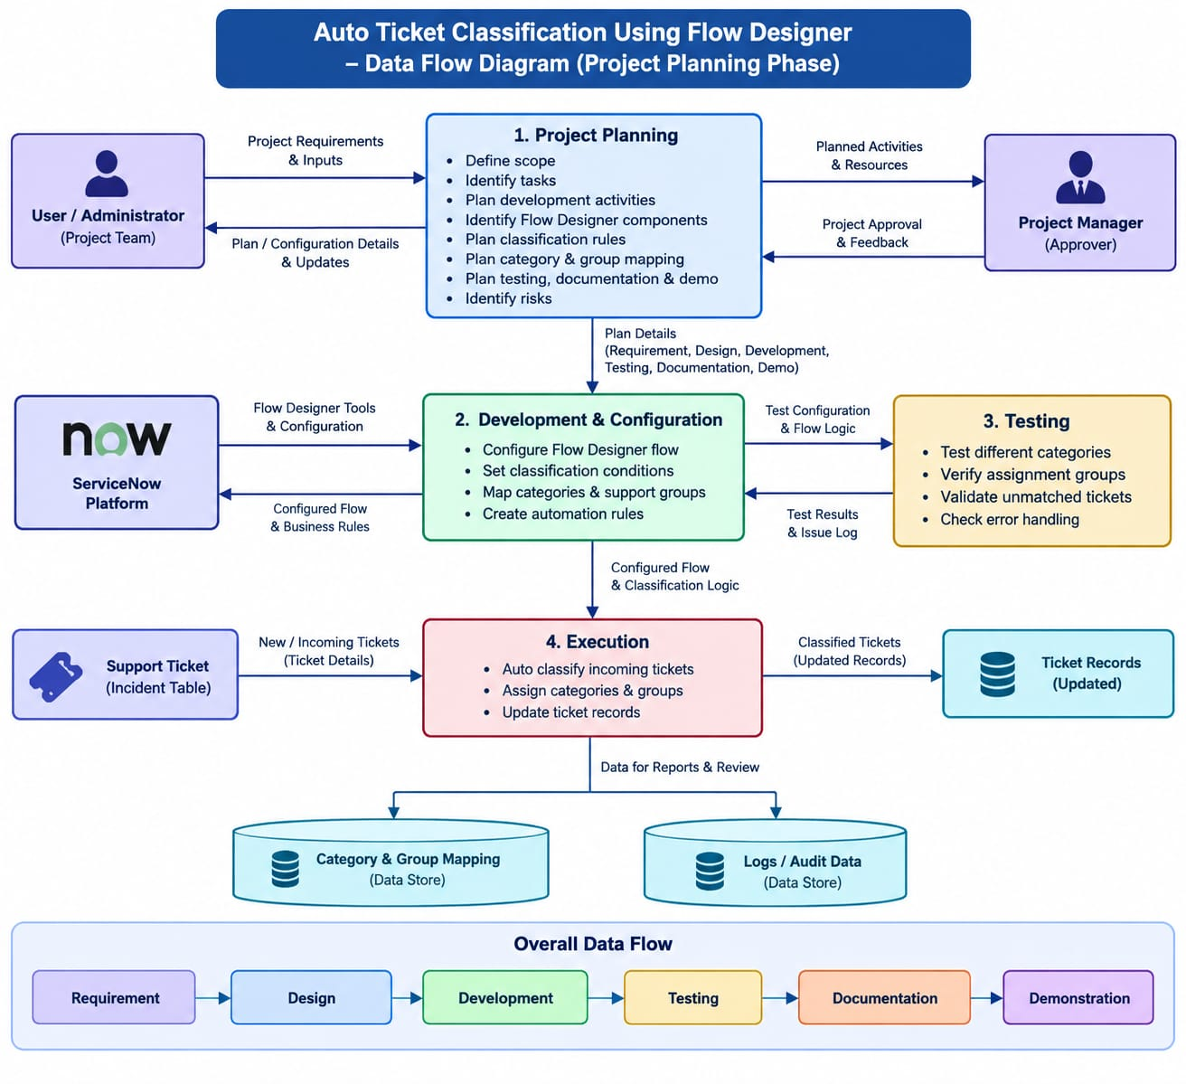

Conclusion

The project planning phase provides a structured approach for completing the Auto Ticket Classification project. It ensures that development, testing, documentation, and demonstration activities are performed systematically.

